Final Lab

# Main Menu

### Add user

### Modify user

#### Add user to group

#### Remove user from group

#### Back

#### Invalid choose

### List users

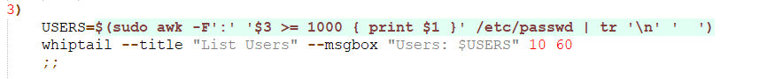

### Enable user

### Disable user

### Change user password

### Back

### Invalid choose



## Group menu

### Add Group

### modify Group

#### Add user to group

#### Remove user from group

#### Back

### List Groups



### Back

### Invalid choose



## Exit

